Dorchester Day Parade Committee
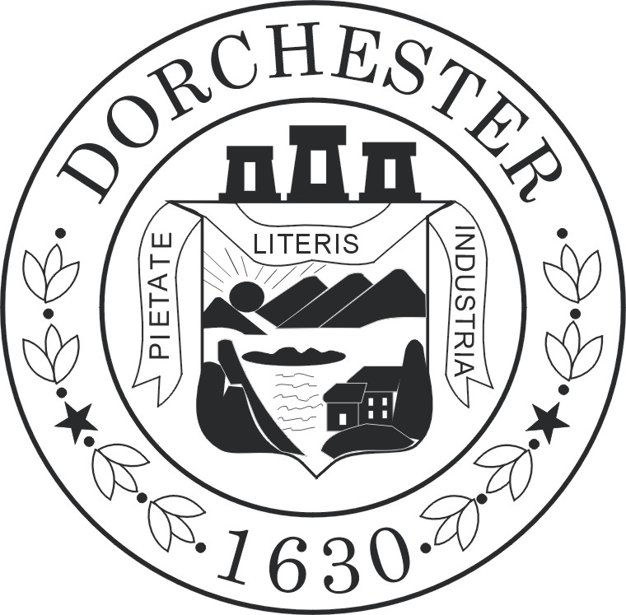

Little Miss & Young Miss

Dorchester Contests
Both age groups will be together for this event, with all winners announced at the end of this special day!

Saturday, May 14th, 2016 ♥ 11am
First Parish Church ∙ 10 Parish Street Meetinghouse Hill

All girls entering the contest must be:

- Residents of Dorchester
- Able to participate in the Dorchester Day Parade, June 5, 2016
- Able to provide a copy of their birth certificate if they win or are a runner-up
- Attach their response to one of the offered questions and read/recite it the day of the contest
- Little Miss Contestants must be 7-8-9 years old on the day of the contest
- Young Miss Contestants must be 10-11-12 years old on the day of the contest

Judges’ final decision will determine the winner and runners up of the Little Miss and Young Miss Dorchester Contest 2016.

The following application (copies accepted) must be completed and mailed (post-marked) no later than Friday, MAY 6. Please enclose a photo (no larger than 4X6) of the contestant. This will be used to assist our judges with their deliberation. All photos will be returned the day of the Little Miss and Young Miss Dorchester contest. The winner and runners-ups MUST submit a birth certificate documenting the child’s age by Friday, May 20. Contestants who do not meet the age requirement will be immediately disqualified.

Confirmation packets will be mailed to all contestants prior to the event. Please contact Annissa Essaibi George at (617) 594-1841 or email littlemiss@dotdayparade.com with additional questions.

Applications must be mailed to: Application Checklist:

The Miss Dorchester Contests □ Completed Application

C/o Annissa Essaibi-George □ Response to selected question

32 Mayhew Street □ Photo
Dorchester, MA 02125

Dorchester Day Parade Committee

Little Miss & Young Miss

Dorchester Contests

Saturday, May 14th, 2016 ♥ 11am
First Parish Church ∙ 10 Parish Street Meetinghouse Hill

Contestant Information

First Name Middle Name Last Name

Street Address Zip Code Phone Number

Date of Birth School Attending Grade

Parent/Guardian Information

First Name Last name Cellular Phone

Email address

LITTLE MISS: Attach a type written or neatly printed response to the following question. Contestants will be asked to read or recite their response the day of the contest. Response should be no more than 50 words in length. A parent, teacher or other adult can assist with this response but the contestant must be able to read or recite their response at the contest. It does not need to be recited exactly as written but the theme of the response should be the same. The judges recognize the younger contestants may not be as articulate as the older contestants. Please encourage all girls to do their best and keep a copy for her to practice!

Describe your favorite place in Dorchester.

YOUNG MISS: Attach a type written or neatly printed response to the following question. Contestants will be asked to read or recite their response the day of the contest. Response should be between 100 and 200 words in length. A parent, teacher or other adult can assist with editing this response but it must be the work and idea of the contestant. It does not need to be recited exactly as written but the theme of the response should be the same. The judges recognize the younger contestants may not be as articulate as the older contestants. Please encourage all girls to do their best and keep a copy for her to practice!

Dorchester is a wonderful place to live. Why do you agree with this statement?

